**Assignment 02 – GitHub Workflow Dry‑Run 🌐**

🚦Step‑by‑step

Screenshots count! Grab a screenshot at each 🚀 emoji and store them in a folder called screenshots/.

**1 . Fork 🚀**

Visit the GitHub link given by your instructor.

Click Fork → select your account.

Confirm you’re now at github.com/<you>/<repo‑name>.

**2 . Clone 🚀**

git clone https://github.com/<your‑user>/<repo‑name>.git

cd <repo‑name>

**3 . Add a file 🚀**

# Bash

echo "My first lab ⭐" > hello-ironboard.txt

# PowerShell alternative:

# 'My first lab ⭐' > hello-ironboard.txt

**4 . Stage & Commit 🚀**

git add hello-ironboard.txt

git commit -m "Add hello-ironboard.txt for Assignment 02"

Check with git status.

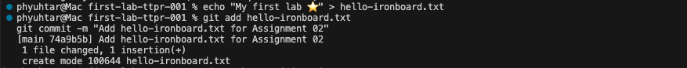

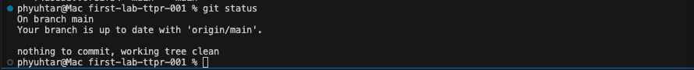

**5 . Push 🚀**

git push -u origin main # use master if that’s the default branch

**6 . Open a Pull Request 🚀**

Go to your fork on GitHub.

Click Compare & pull request.

Title: Complete Assignment 02

Click Create pull request.

**📝 Reflection**

Create REFLECTION.md answering:

Which step felt least clear?

Why do we fork instead of pushing directly to the instructors’ repo?

git add REFLECTION.md

git commit -m "Add reflection"

git push

✅ Check before you submit

 hello-ironboard.txt present

 screenshots/ with at least four images

 REFLECTION.md added

 PR shows green checks

Paste your PR link in the LMS when done.

https://github.com/hhassan1230/first-lab-ttpr-001/pull/2

💡 Troubleshooting

| Problem | Fix |
| --- | --- |
| Auth errors | Ensure you accepted the org invite; use HTTPS. |
| On wrong branch name | git branch -M main then push again. |
| Forgot a file | Add → commit → push; the PR updates automatically. |

Happy Git‑ing! 🚀